Date | Category | Subcategory | Value | Value2 | Latitude | Longitude | Lower | Upper | Freq
01-01-2024 | A | X | 50 | 30 | 11.01 | 76.95 | 45 | 55 | 10
02-01-2024 | A | Y | 60 | 35 | 11.02 | 76.96 | 55 | 65 | 15
03-01-2024 | B | X | 40 | 25 | 11.03 | 76.97 | 35 | 45 | 12
04-01-2024 | B | Y | 70 | 45 | 11.04 | 76.98 | 65 | 75 | 18
05-01-2024 | C | X | 55 | 33 | 11.05 | 76.99 | 50 | 60 | 14
06-01-2024 | C | Y | 65 | 38 | 11.06 | 77 | 60 | 70 | 16
Dataset

1.

Bar plot

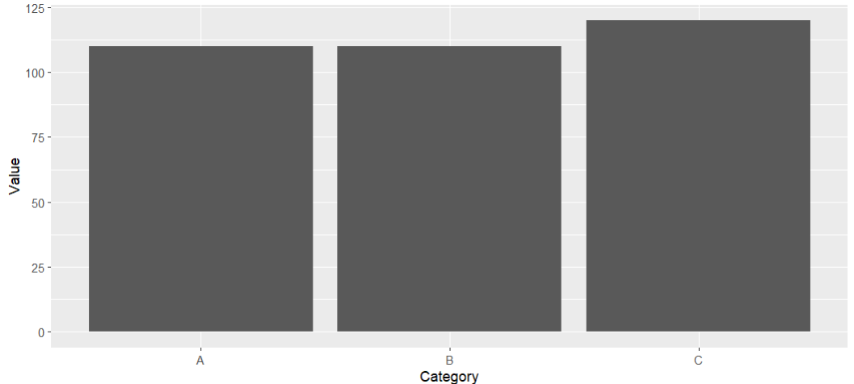

2.grouped bar plot

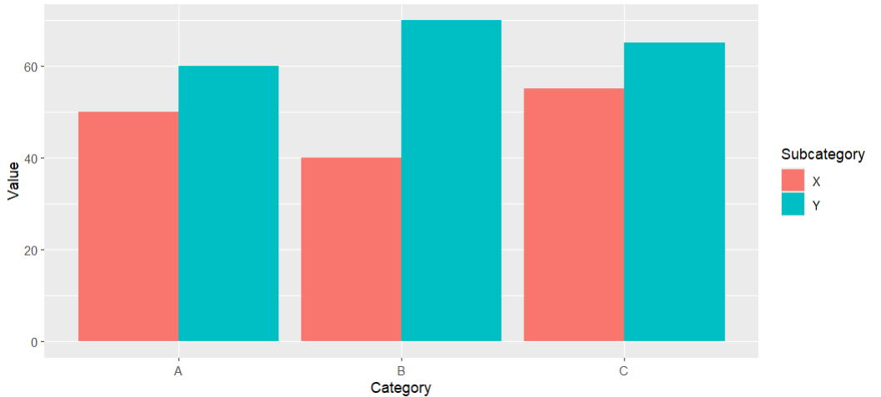
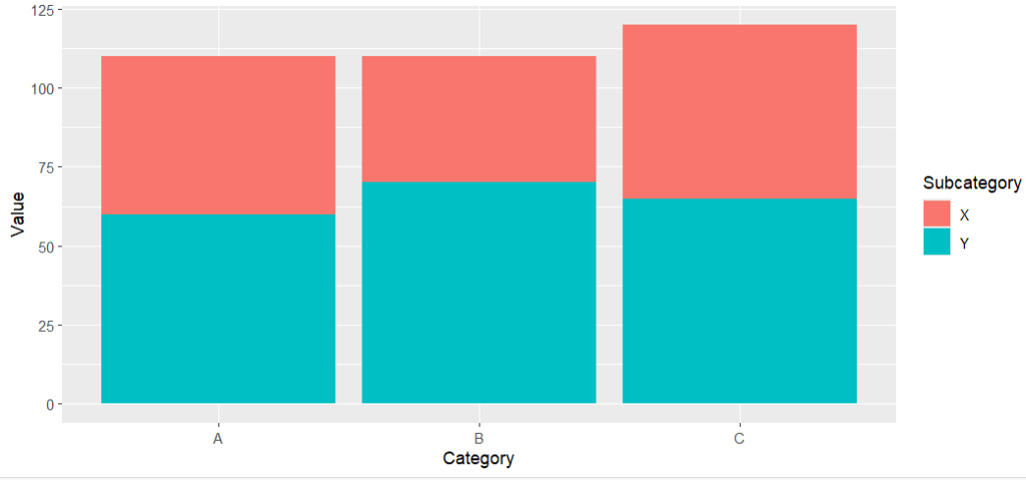

3.stacked bar chart

4.Dot Plot

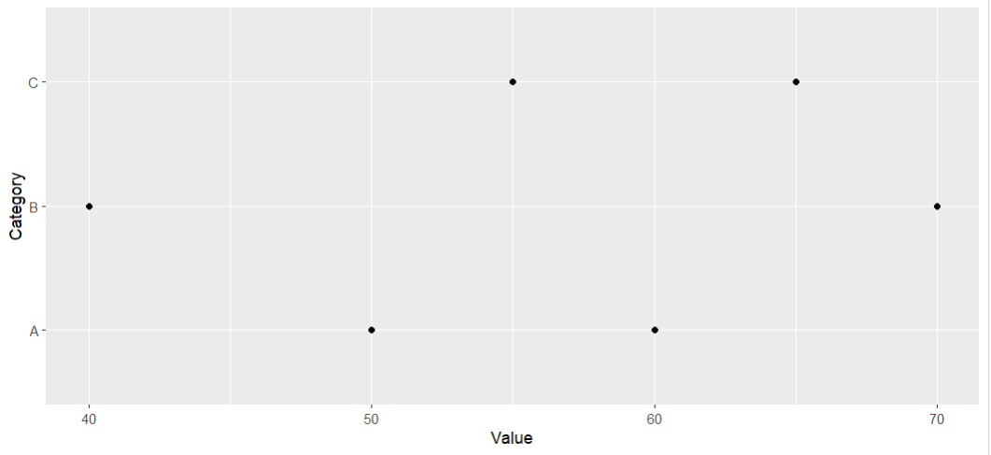

5.Heatmap

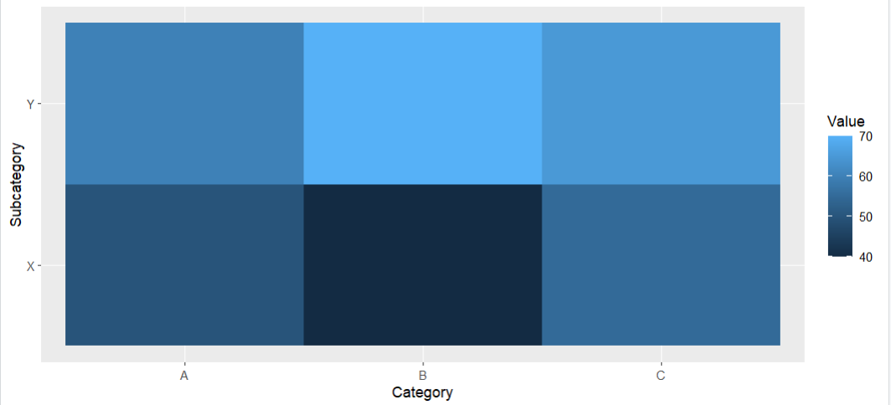

6.Violin Plot

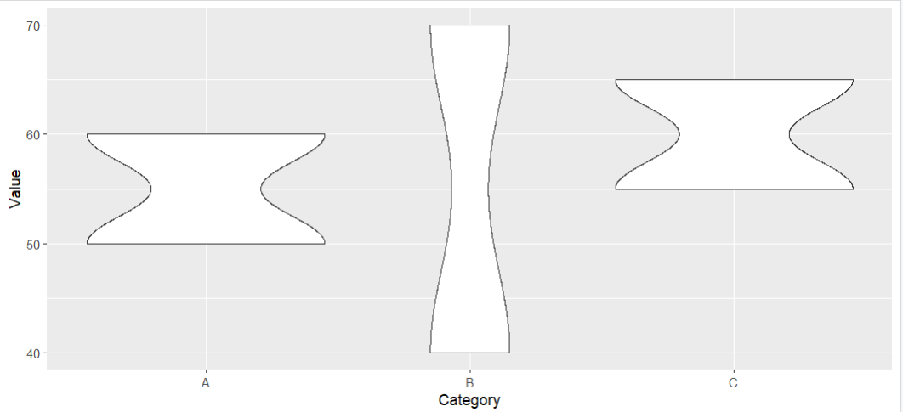

7.Ridgeline Plot

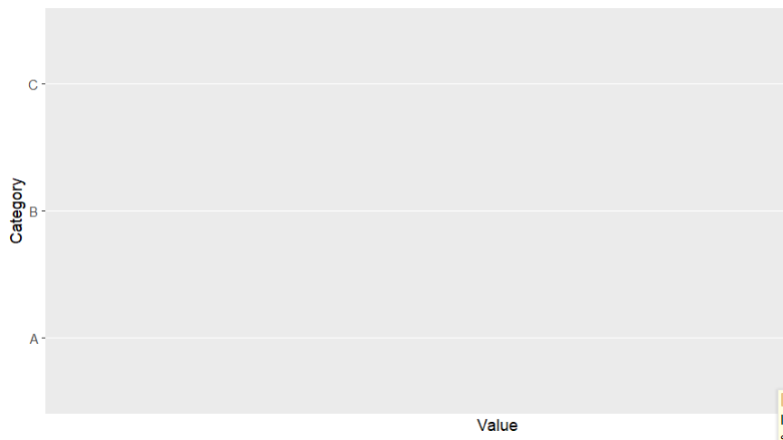
8.Histogram

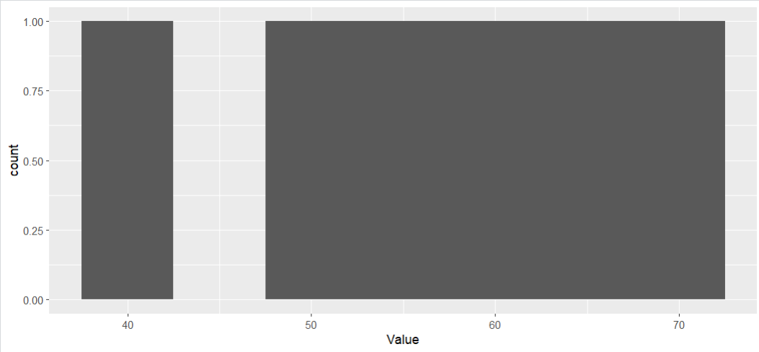

9.Density Plot

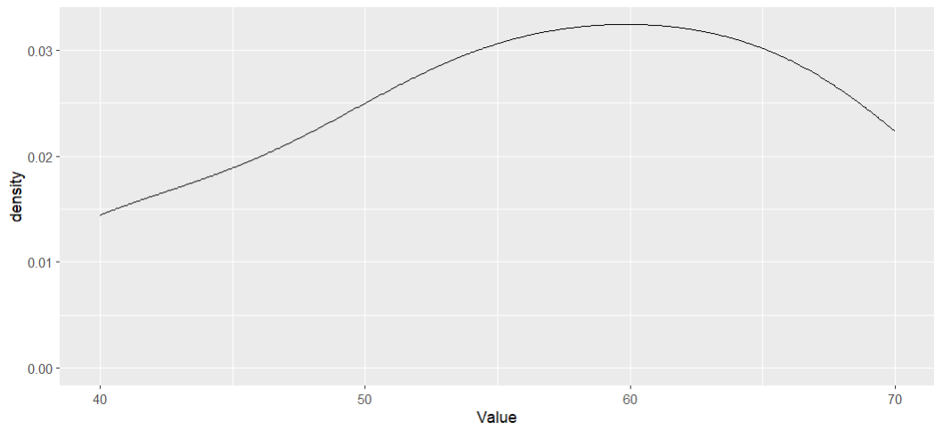
10.Box plot

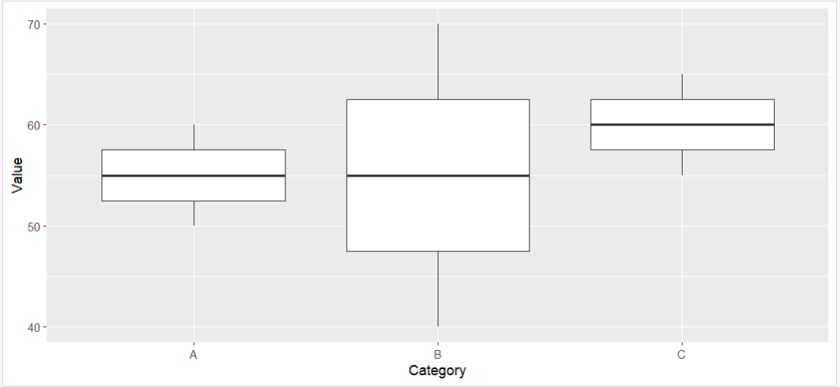
11.
Pie chart

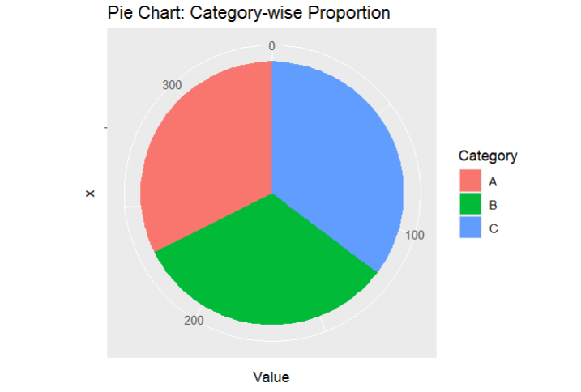

12.stacked bar chart

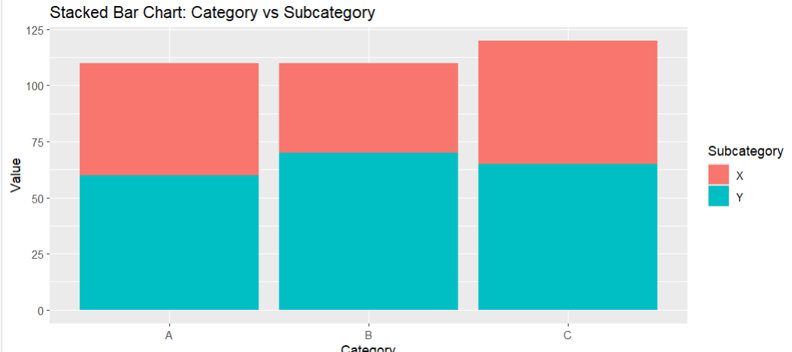
13.Treemap

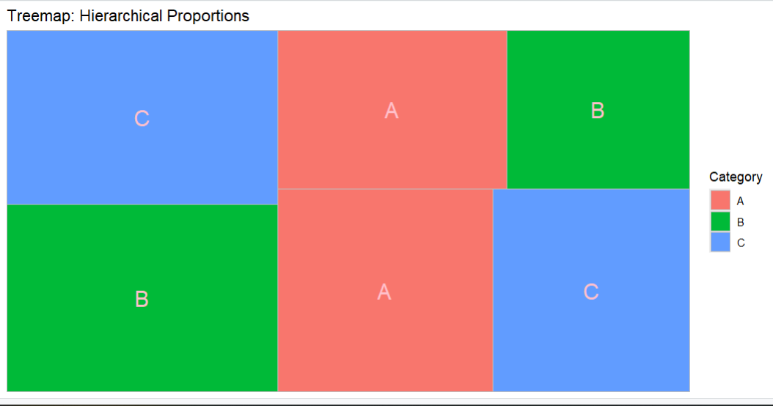
14,SUNBURST CHART

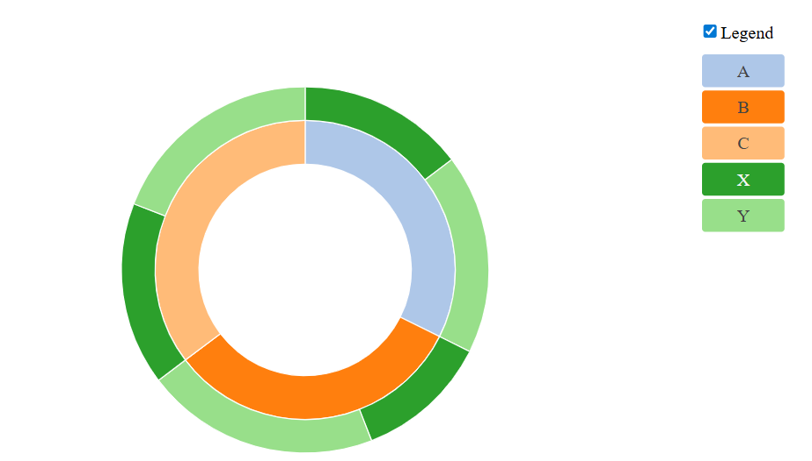

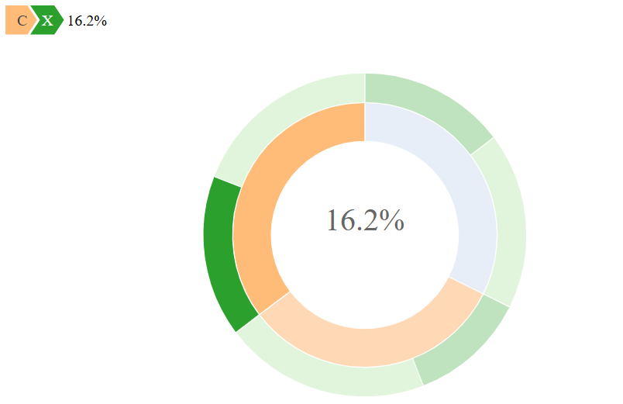
15.PARALLEL SETS

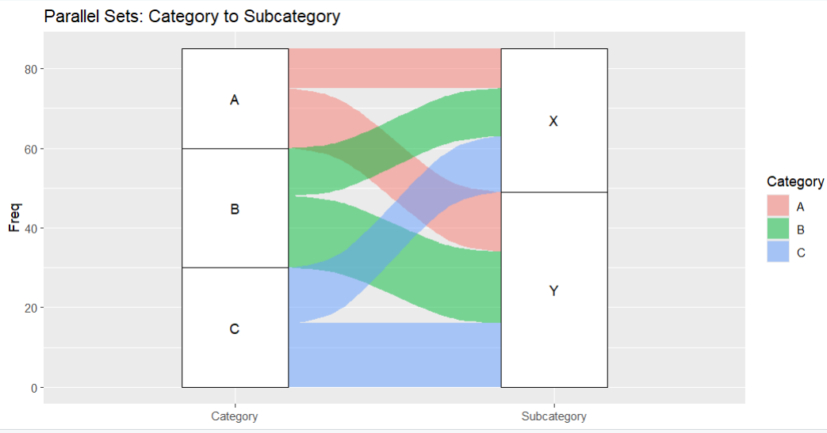
16.SANKEY DIAGRAM

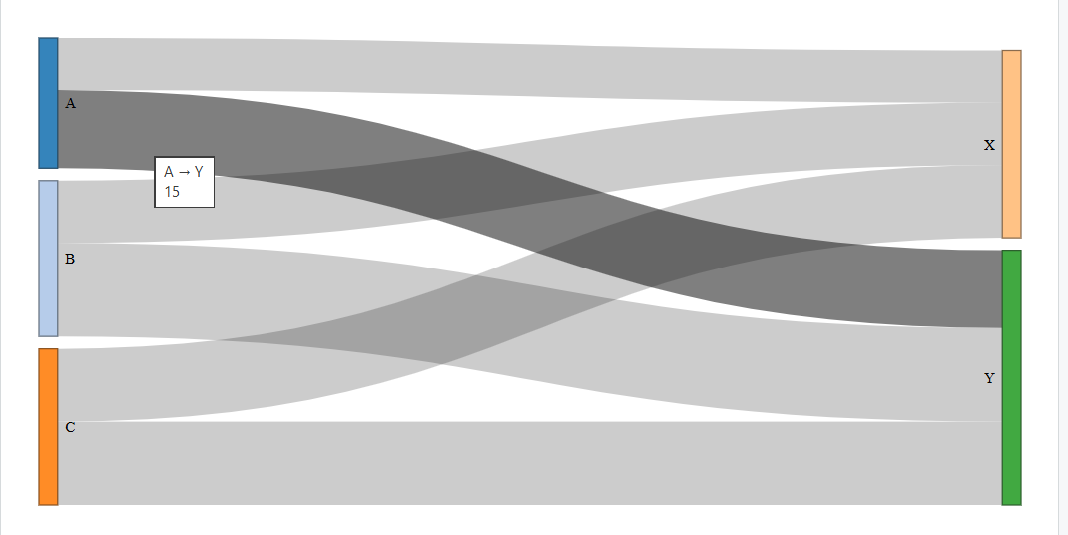
17
Scatter plot
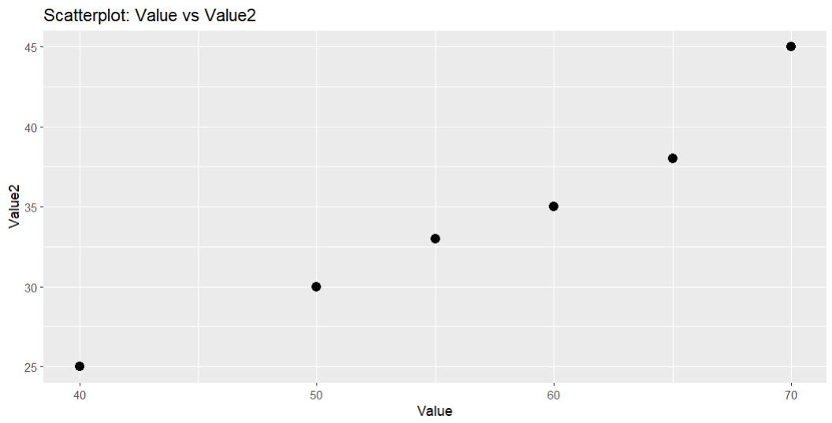

18.Bubble chart

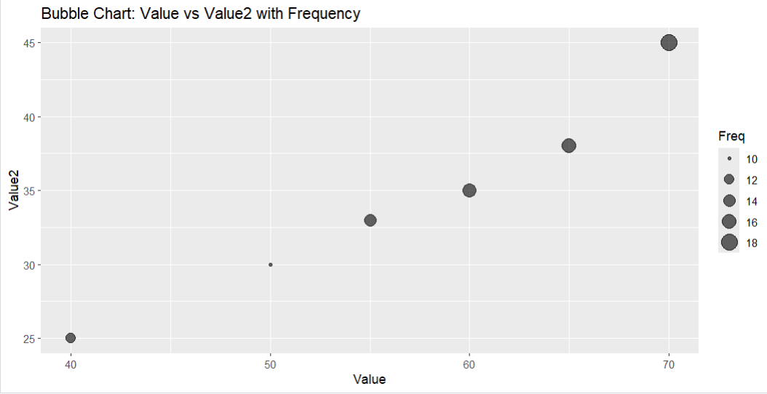
19.Hexbin chart

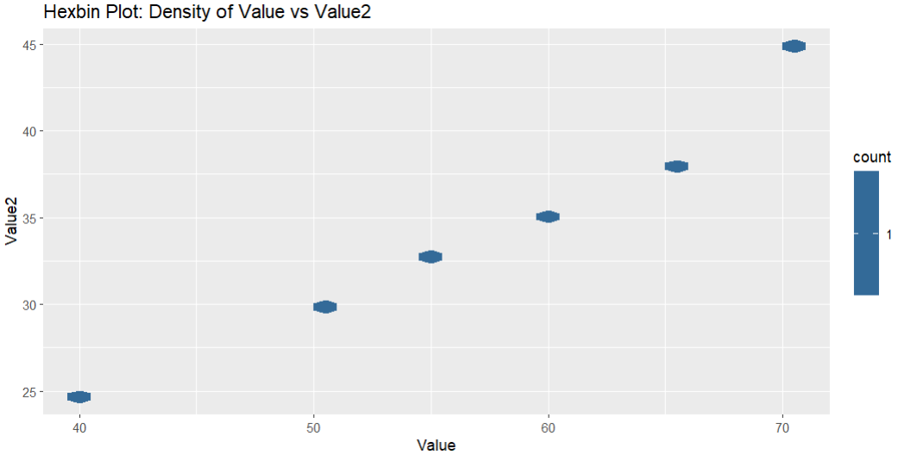
20.CORRELOGRAM

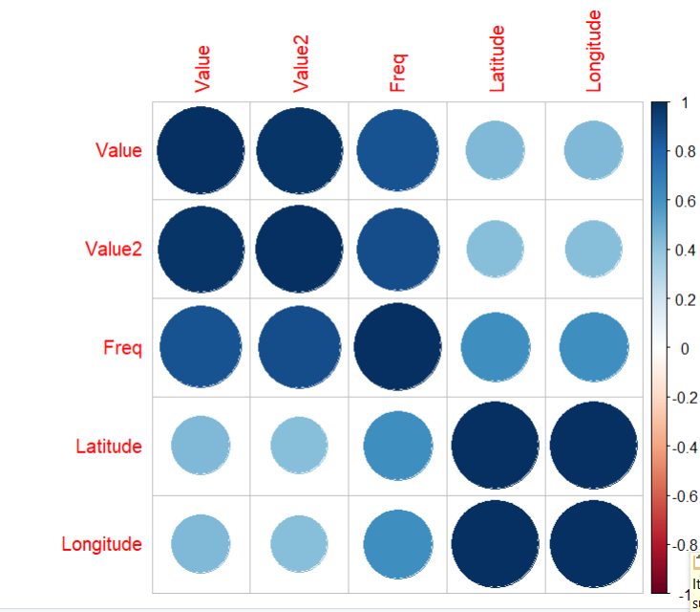

21.
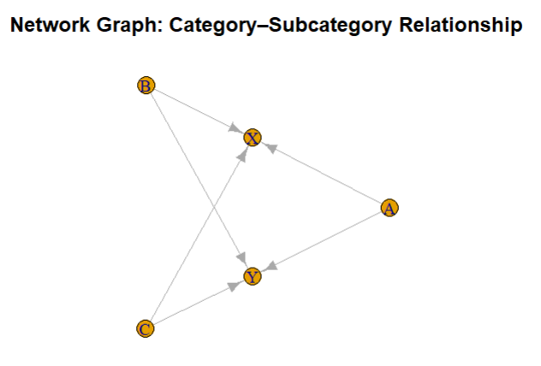

22.PCA

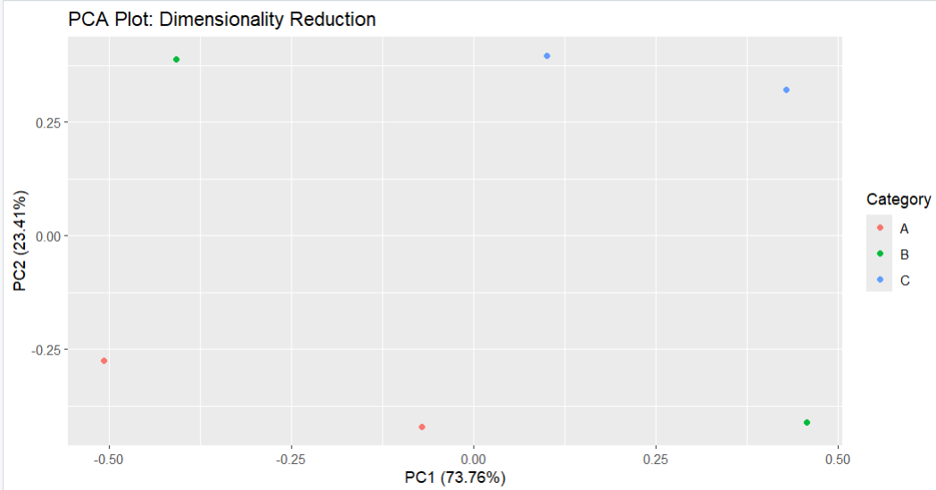
23.
Line plot

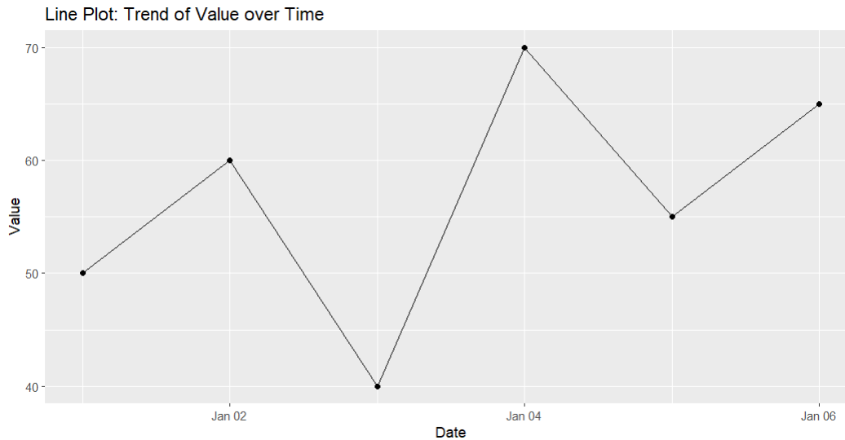
24.Multiple line plot

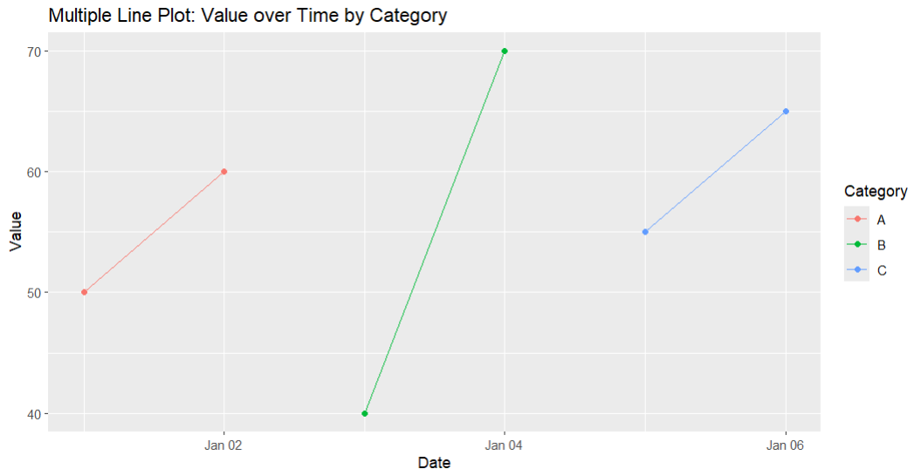
25.DOSE–RESPONSE CURVE

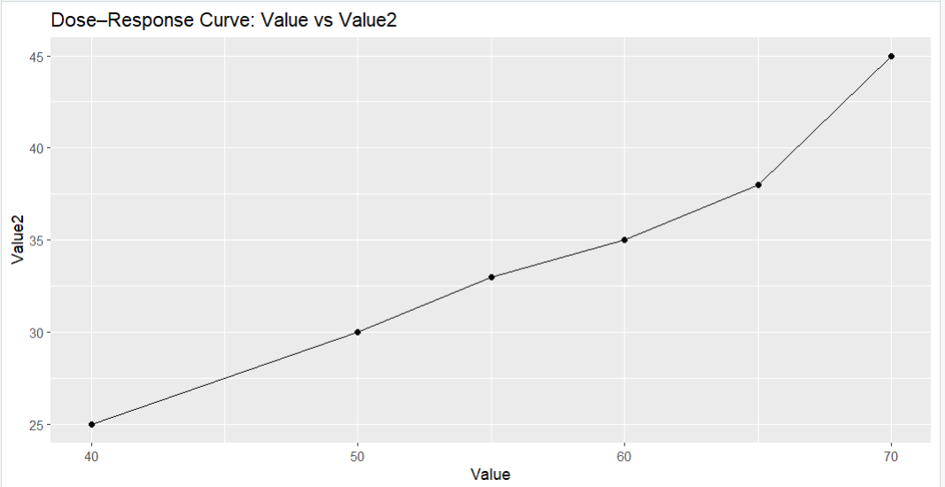
26.Seasonal decomposition
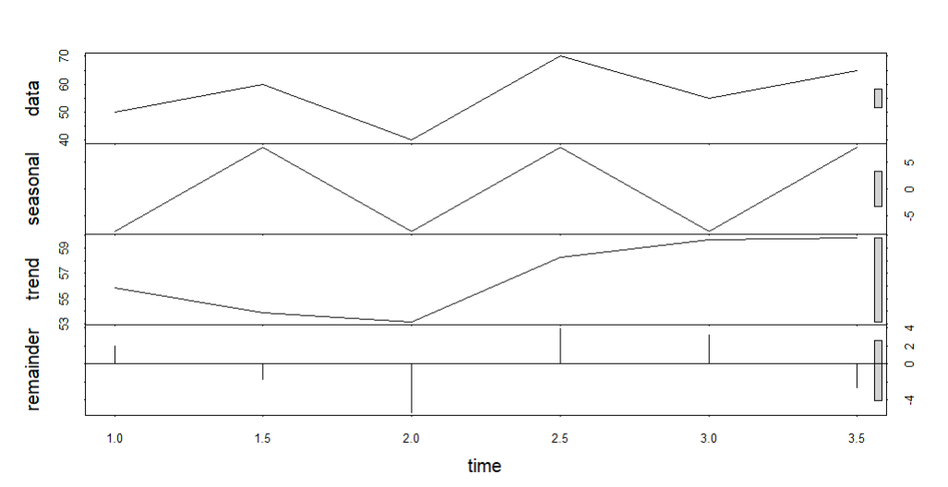
27.Smoothing

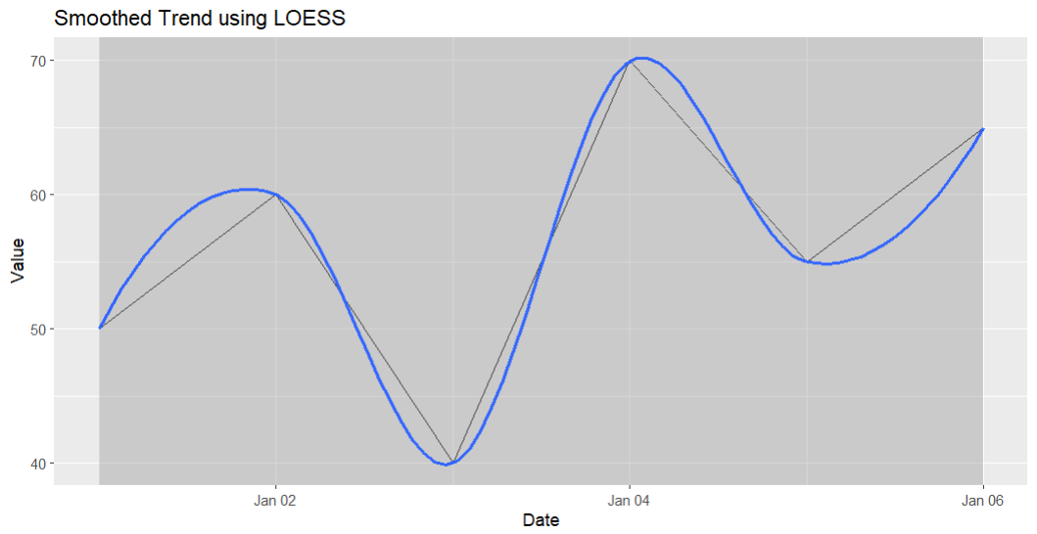
28.
SPATIAL HEATMAP (DENSITY)

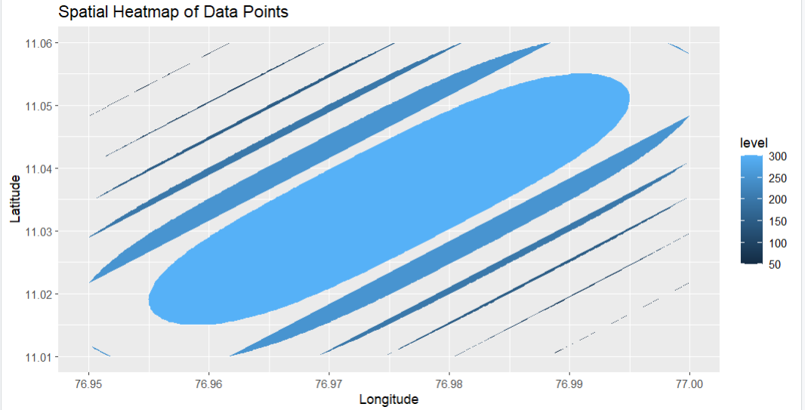
29.INTERACTIVE MAP
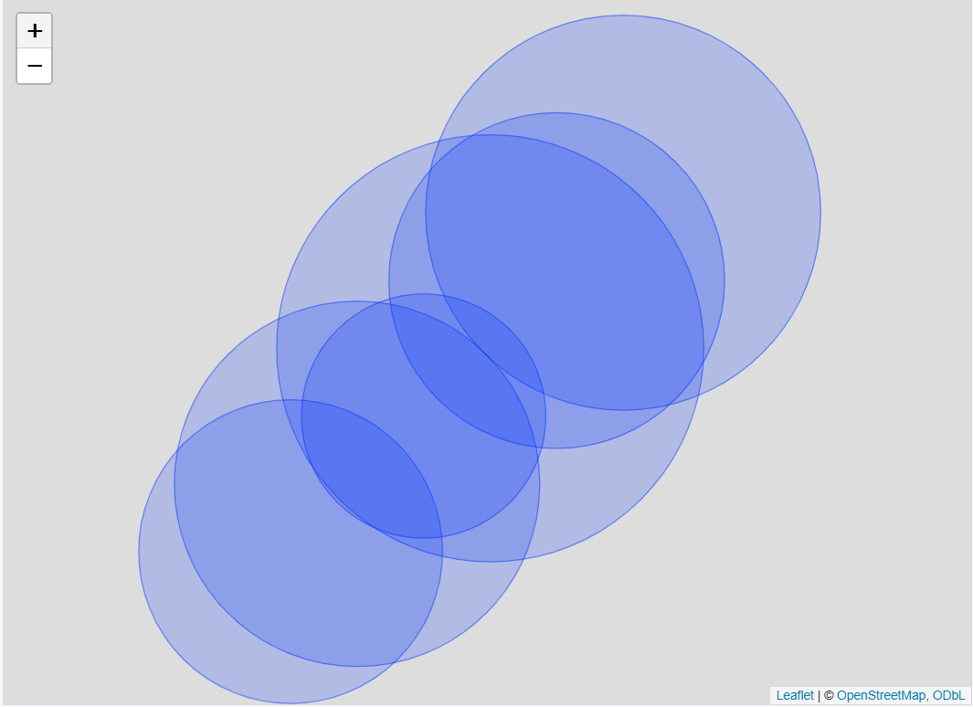
31.. CONFIDENCE INTERVAL PLOT

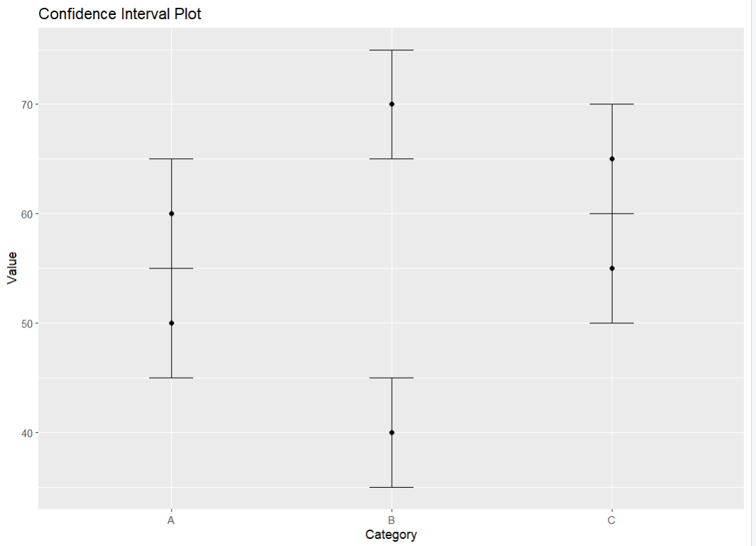

32.BOOTSTRAPPING / HYPOTHETICAL OUTCOMES

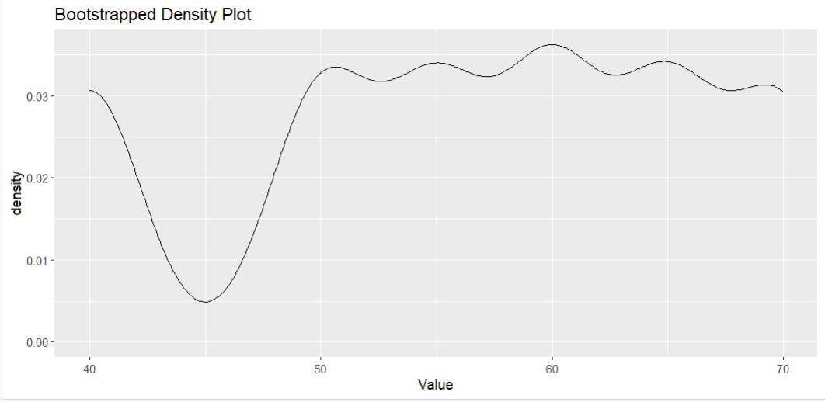
33.PARTIAL TRANSPARENCY & JITTER

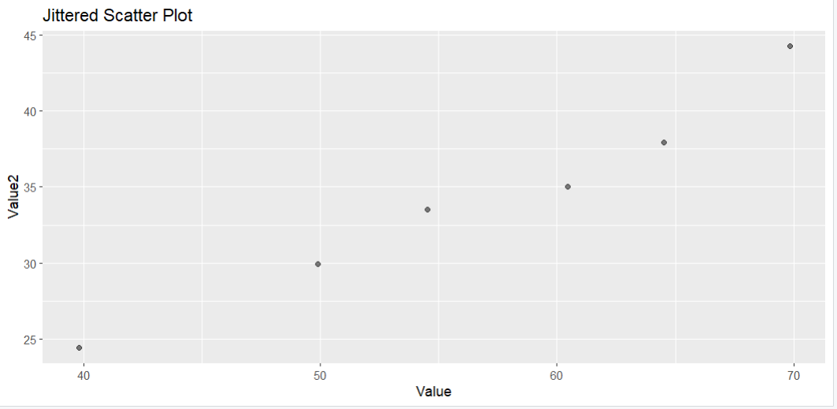

34.2D HISTOGRAM / DENSITY

